The Normal Distribution: Practice;
The Normal Distribution

Student Learning Outcomes:

- The student will explore the properties of data with a normal distribution.

Given:

The life of Sunshine CD players is normally distributed with a mean of 4.1 years and a standard deviation of 1.3 years. A CD player is guaranteed for 3 years. We are interested in the length of time a CD player lasts.

Normal Distribution

1. Define the Random Variable X in words.
X =

2. X ∼ _______________

3. Find the probability that a CD player will break down during the guarantee period.

- Sketch the situation. Label and scale the axes. Shade the region corresponding to the probability.

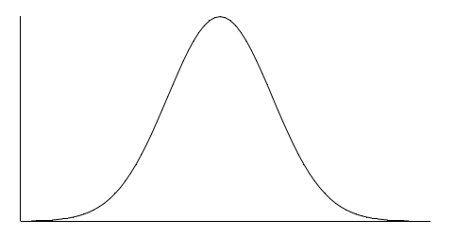

b. P(0 < X < __________ ) = __________

4. Find the probability that a CD player will last between 2.8 and 6 years.

a. Sketch the situation. Label and scale the axes. Shade the region corresponding to the probability.

b. P( _____ < X < _____ ) = __________

5. Find the 70th percentile of the distribution for the time a CD player lasts.

a. Sketch the situation. Label and scale the axes. Shade the region corresponding to the lower 70%.

b. P(X < k) = __________ . Therefore, k = __________ .

